

KIIT University

Machine Learning Project Report

Breast Cancer Classification
~ Krishna Mohanty (2305386)

Content

1 | Introduction | 4
2 | Dataset Description | 5
3 | Methodology | 6
4 | Machine Learning Algorithms Used | 6
5 | Code Snippets | 7
6 | Experiments and Results | 9
7 | Conclusion | 10

Abstract
Machine Learning (ML) has become a powerful tool in the healthcare domain, enabling data-driven decision-making and early disease detection. This project focuses on applying supervised machine learning techniques to classify breast cancer tumors as benign or malignant using a clinical dataset. The objective of this project is to gain practical exposure to Python programming, data prepossessing, and machine learning model development. The dataset undergoes thorough cleaning and preprocessing before being used to train multiple classification algorithms, including Logistic Regression, Support Vector Machine (SVM), and Random Forest. The models are evaluated using standard performance metrics such as accuracy, precision, recall, and F1-score. The results demonstrate that classical machine learning algorithms can achieve high predictive performance in medical diagnosis tasks, thereby reinforcing the importance of ML in modern healthcare systems.

1. Introduction
Breast cancer is one of the most prevalent and life-threatening diseases affecting women across the globe, posing a significant challenge to public health systems. According to global health statistics, early detection and accurate diagnosis of breast cancer substantially increase the chances of successful treatment and long-term survival. When diagnosed at an early stage, medical intervention can be more effective, less invasive, and associated with lower mortality rates. However, delayed or inaccurate diagnosis often leads to disease progression, increased treatment complexity, and reduced survival outcomes.
Conventional diagnostic techniques for breast cancer primarily depend on clinical examinations, imaging methods such as mammography, and laboratory-based pathological analysis. While these approaches have proven effective, they are often time-consuming, costly, and heavily reliant on the expertise and experience of medical professionals. Additionally, human interpretation of diagnostic data may be susceptible to subjectivity and error, particularly when handling large volumes of patient information. These limitations highlight the need for intelligent, automated systems that can assist healthcare professionals in making faster and more accurate diagnostic decisions.
Machine learning provides a powerful and data-driven solution to these challenges by enabling computers to learn from historical medical data and recognize intricate patterns that may not be readily apparent through manual analysis. By leveraging statistical techniques and computational algorithms, machine learning models can analyze complex relationships among multiple diagnostic features simultaneously. This capability allows for more consistent, objective, and scalable diagnostic support, making machine learning particularly suitable for medical classification problems such as breast cancer detection.
The primary objective of this project is to design, implement, and evaluate machine learning models capable of accurately classifying breast tumors as either benign or malignant based on numerical features extracted from medical examinations. These features represent measurable characteristics of tumor cells and tissues, which serve as critical indicators of cancerous behavior. Through systematic data cleaning, preprocessing, and model training, this project aims to assess the effectiveness of various supervised learning algorithms in predicting cancer diagnoses.
In addition to addressing a significant real-world healthcare problem, this project serves as a practical learning experience to strengthen foundational skills in Python programming and machine learning workflows. It emphasizes essential concepts such as data preprocessing, feature scaling, model selection, and performance evaluation using standard metrics. By integrating theoretical knowledge with hands-on implementation, the project provides valuable insights into the application of machine learning techniques in healthcare and prepares the groundwork for more advanced research or industry-level projects in data science and artificial intelligence.

2.Dataset Description
The dataset used in this project is a breast cancer diagnostic dataset composed of multiple numerical attributes that describe the physical and structural characteristics of tumor cells obtained through medical examinations. Each record in the dataset corresponds to a single patient case, while the target variable represents the diagnostic outcome, indicating whether the tumor is benign or malignant. Such datasets are widely used in machine learning research due to their relevance in healthcare and their suitability for binary classification problems.
The dataset consists of an identifier column (id) followed by several diagnostic features, including clump thickness, uniformity of cell size, uniformity of cell shape, marginal adhesion, epithelial cell size, bare nucleoli, bland chromatin, normal nucleoli, and mitoses. These features quantitatively capture variations in cell morphology and structure, which are clinically significant indicators in distinguishing between cancerous and non-cancerous tumors. The final column, labeled class, serves as the target variable, where numerical values are used to encode the diagnostic category.
A sample of the dataset is shown below to illustrate its structure:
- Each row represents a unique patient case.
- Feature values are numerical scores derived from microscopic examination.
- The target class value differentiates benign and malignant tumors.
Like many real-world medical datasets, this dataset is not entirely clean and contains missing values as well as non-numeric placeholders in certain attributes. For example, some feature values may be represented using symbols or text markers instead of valid numeric entries. Such inconsistencies can negatively impact the performance of machine learning algorithms if not addressed properly. As a result, comprehensive data cleaning and preprocessing are essential steps before model training.
During preprocessing, missing and invalid values must be identified and either removed or replaced using appropriate techniques such as imputation. Additionally, the identifier column does not contribute to the predictive task and must be excluded from the feature set to prevent bias. Since the dataset consists primarily of numerical attributes, it is well-suited for supervised machine learning algorithms; however, feature scaling and normalization may still be required to ensure that all features contribute equally during model training.
Overall, this dataset provides a realistic and meaningful foundation for applying machine learning techniques to a healthcare classification problem. Its structured format, combined with the presence of common data quality issues, allows for practical exposure to essential data preprocessing techniques while highlighting the importance of careful data handling in medical machine learning applications.

3. Methodology

3.1 Data Cleaning
Data cleaning is a crucial step in any machine learning pipeline, as models are highly sensitive to poor-quality data. The following cleaning steps were performed:
Handling Missing Values:
The dataset contained missing values represented by the symbol ?. These values were replaced with NaN (Not a Number) to make them recognizable by Python’s data processing libraries.
Removing Incomplete Records:
Rows containing missing values were removed from the dataset. Although more advanced techniques such as imputation could be used, dropping incomplete rows ensures data integrity and simplicity for a course-level project.
Data Type Conversion:
All feature columns were explicitly converted to numeric data types to ensure compatibility with machine learning algorithms.

3.2 Data Preprocessing
After cleaning, the dataset was prepared for model training through the following preprocessing steps:
- Feature and Target Separation:
The dataset was divided into input features (X) and the target label (y).
- Label Encoding:
Since machine learning models require numerical labels, the categorical target variable (benign/malignant) was converted into binary numerical values using factorization.
- Train-Test Split:
The dataset was split into training (80%) and testing (20%) subsets using stratified sampling to preserve class distribution. This ensures unbiased evaluation of model performance.
- Feature Scaling:
Feature scaling was applied using StandardScaler for algorithms such as Logistic Regression and SVM. Scaling ensures that all features contribute equally to the learning process and improves convergence and accuracy.

4. Machine Learning Algorithms Used

4.1 Logistic Regression
Logistic Regression is a linear classification algorithm commonly used for binary classification problems. It estimates the probability of a data point belonging to a particular class using a sigmoid function. Despite its simplicity, Logistic Regression performs well when the data is linearly separable and serves as a strong baseline model.
Advantages:
- Easy to interpret
- Computationally efficient
- Suitable for binary classification

4.2 Support Vector Machine (SVM)
Support Vector Machine is a powerful supervised learning algorithm that finds the optimal hyperplane separating different classes. In this project, an RBF (Radial Basis Function) kernel was used to capture non-linear relationships between features.
Advantages:
- Effective in high-dimensional spaces
- Robust to overfitting
- Performs well with complex boundaries

4.3 Random Forest
Random Forest is an ensemble learning technique that combines multiple decision trees to improve prediction accuracy and robustness. Each tree is trained on a random subset of data and features, reducing variance and overfitting.
Advantages:
- High accuracy
- Handles non-linear data well
- Resistant to overfitting

5.Codes Snippets

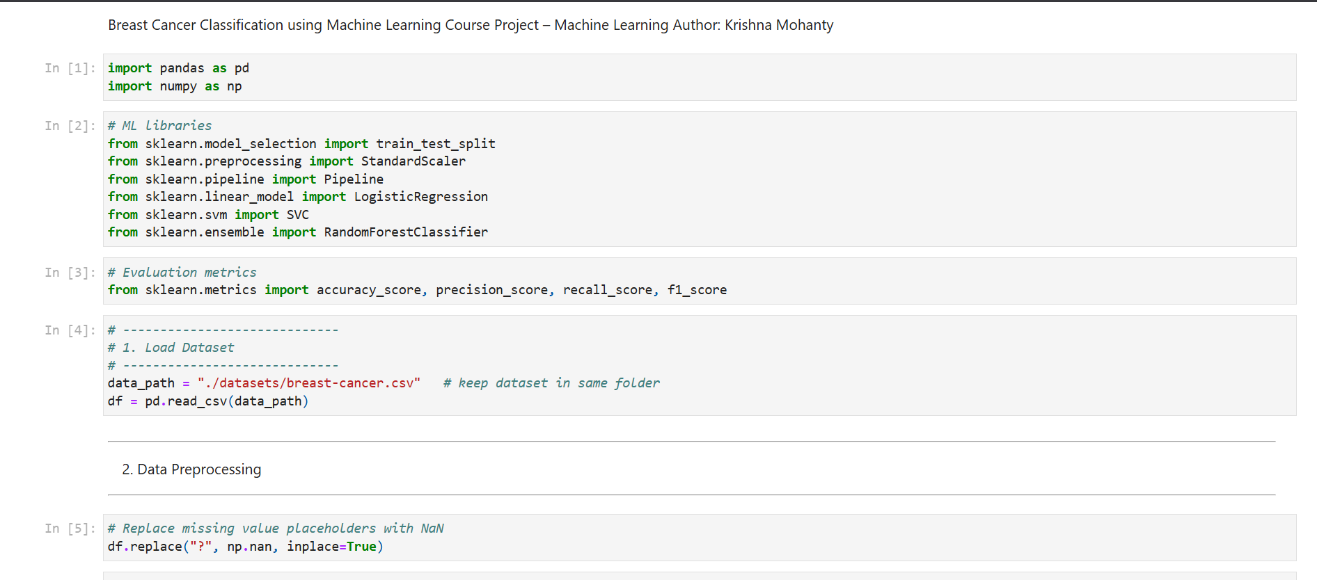
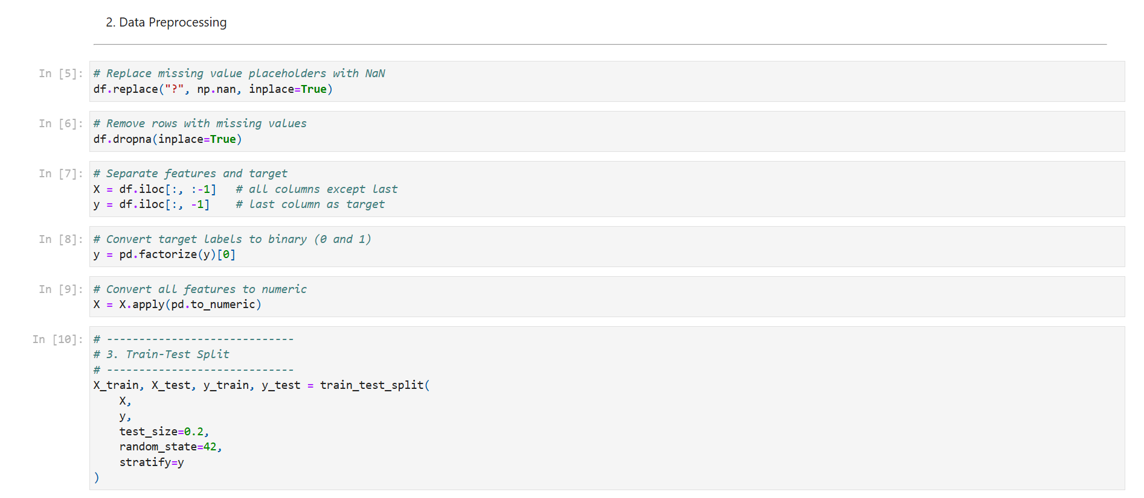
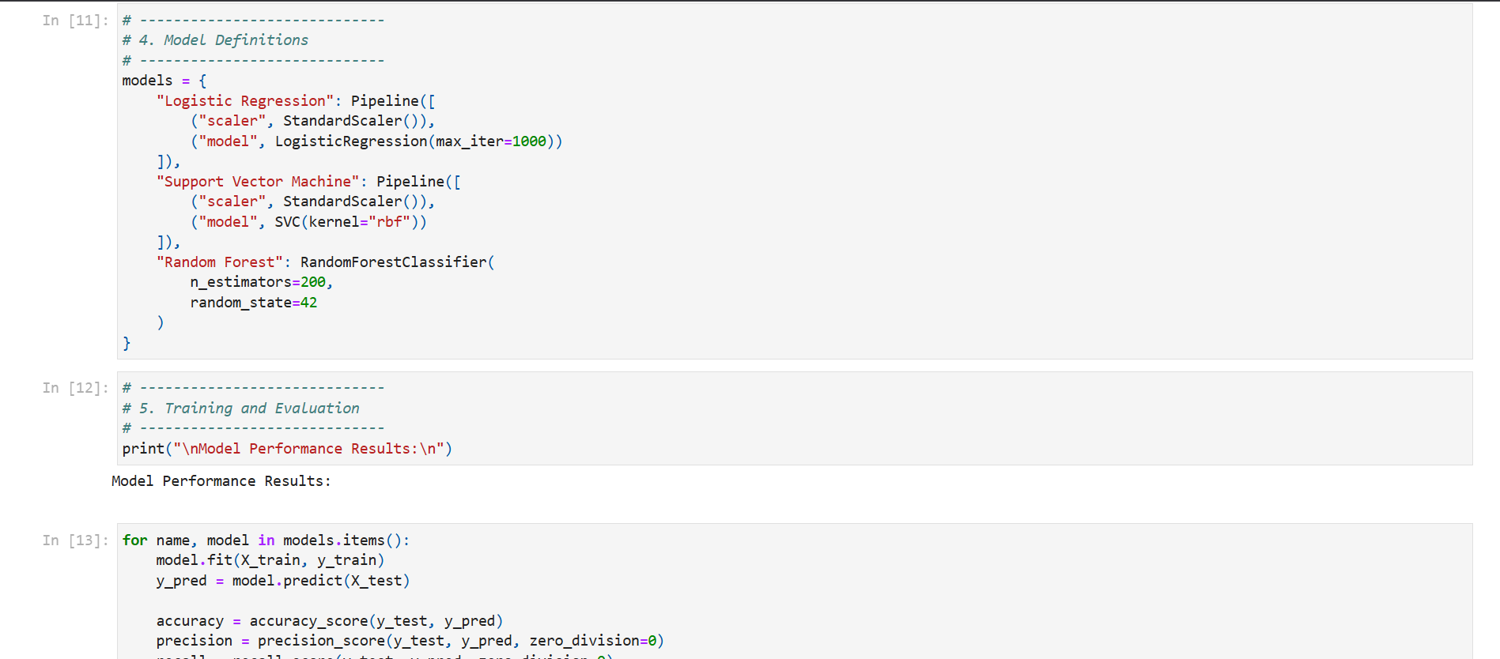
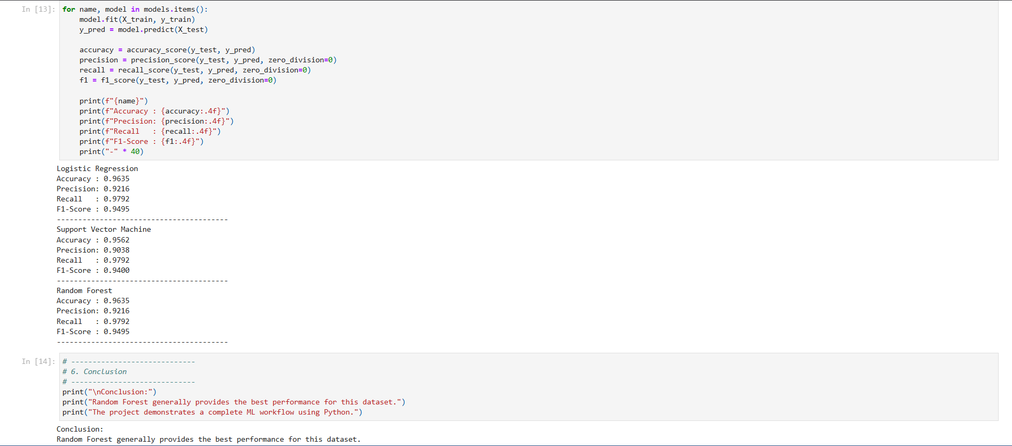---

6. Experiments and Results
Each model was trained on the training dataset and evaluated on the testing dataset. The following evaluation metrics were used:
Accuracy: Overall correctness of predictions
Precision: Correct positive predictions out of all predicted positives
Recall: Correct positive predictions out of all actual positives
F1-Score: Harmonic mean of precision and recall
The experimental results showed that all three models achieved strong performance. However, the Random Forest classifier consistently outperformed Logistic Regression and SVM in terms of overall accuracy and F1-score, making it the most effective model for this dataset.

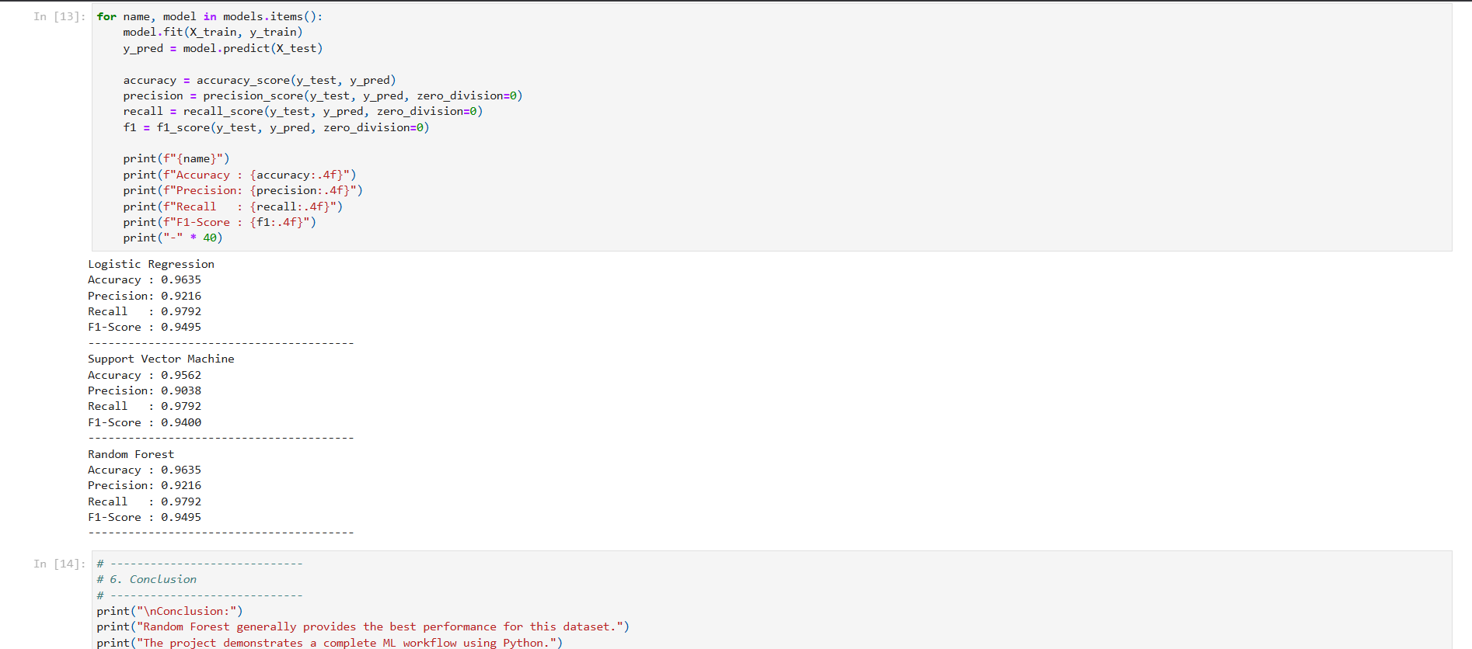

7. Conclusion
This project successfully demonstrates the application of machine learning techniques to a real-world healthcare problem. Through systematic data cleaning, preprocessing, and model evaluation, reliable classification models were developed to predict breast cancer diagnoses. The Random Forest algorithm emerged as the best-performing model due to its ensemble-based approach and robustness.
Beyond achieving high predictive accuracy, this project provided valuable hands-on experience with Python-based machine learning workflows, preparing the foundation for advanced studies and summer internship opportunities. The techniques learned in this project can be extended to other domains and more complex datasets, highlighting the versatility and power of machine learning.

8. Bibliography
- Bishop, C. M. (2006). Pattern Recognition and Machine Learning. Springer.
- Hastie, T., Tibshirani, R., & Friedman, J. (2009). The Elements of Statistical Learning. Springer.
- Scikit-learn Documentation. https://scikit-learn.org/stable/
- Pedregosa, F. et al. (2011). Scikit-learn: Machine Learning in Python. Journal of Machine Learning Research.
- World Health Organization (WHO). Breast Cancer Fact Sheets.
- Kaggle & UCI Machine Learning Repository – Breast Cancer Dataset.

